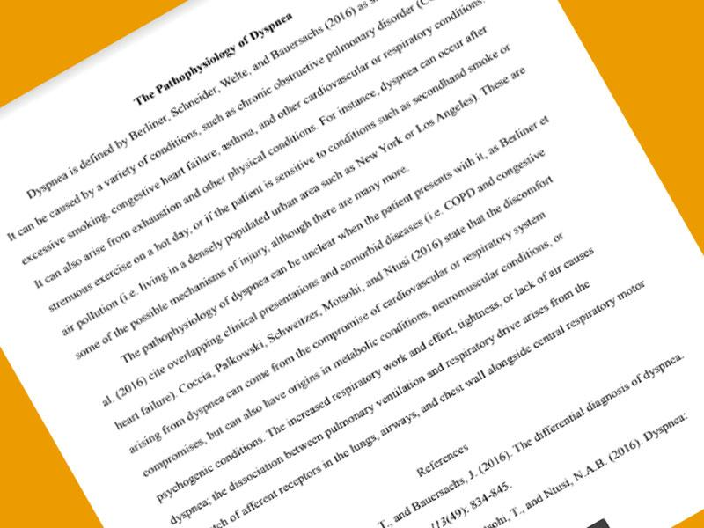

**The Pathophysiology of Dyspnea**

Dyspnea is defined by Berliner, Schneider, Welte, and Bauersachs (2016) as

It can be caused by a variety of conditions, such as chronic obstructive pulmonary disorder excessive smoking, congestive heart failure, asthma, and other cardiovascular or respiratory condition It can also arise from exhaustion and other physical conditions. For instance, dyspnea can occur after strenuous exercise on a hot day, or if the patient is sensitive to conditions such as secondhand smoke or air pollution (i.e. living in a densely populated urban area such as New York or Los Angeles). These are some of the possible mechanisms of injury, although there are many more.

The pathophysiology of dyspnea can be unclear when the patient presents with it, as Berliner et al. (2016) cite overlapping clinical presentations and comorbid diseases (ie. COPD and congestive heart failure). Coccia, Palkowski, Schweitzer, Motsohi, and Ntusi (2016) state that the discomfort arising from dyspnea can come from the compromise of cardiovascular or respiratory system compromises, but can also have origins in metabolic conditions, neuromuscular conditions, or psychogenic conditions. The increased respiratory work and effort, tightness, or lack of air causes dyspnea; the dissociation between pulmonary ventilation and respiratory drive arises from the

of afferent receptors in the lungs, airways, and chest wall alongside central respiratory motor

References

, and Bauersachs, J. (2016). The differential diagnosis of dyspnea.

3(49): 834-845.

sohi, T., and Ntusi, N.A.B. (2016). Dyspnea: